

CS451 Advance computing

Case study



20DCS103

RUSHIK RAJESHBHAI RATHOD

7 DCSE 2 - B

**Title: The Emergence and Potential of Edge Computing in Automotive Industry**

**Introduction**

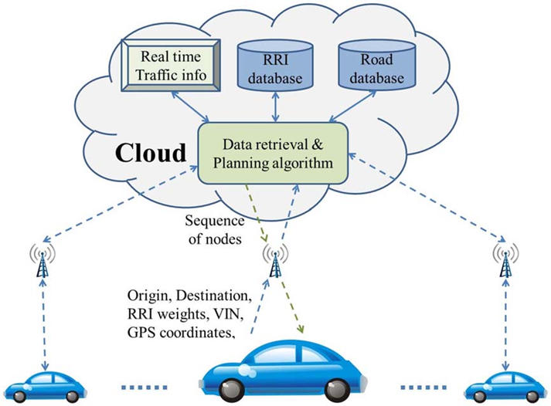

The rapid advancements in modern technologies such as artificial intelligence, machine learning, cloud computing, and others are driving unprecedented changes across industries. One technology that is poised to revolutionize various sectors, particularly in data-intensive applications, is edge computing. While edge computing remains relatively under the radar for mainstream audiences, its significance is expected to surge in the coming years. Tesla, Inc., led by visionary entrepreneur Elon Musk, has become a pioneer in the development of autonomous driving technology. Tesla's Autopilot system, introduced in 2015, has gained significant attention and scrutiny for its advanced driver-assistance features and its ambition to achieve full self-driving capabilities. This case study delves into the evolution, features, challenges, controversies, and future prospects of Tesla's Autopilot system.

**About Tesla**



Tesla, Inc. is an American electric vehicle (EV) and clean energy company founded in 2003 by engineers Martin Eberhard and Marc Tarpenning. Elon Musk joined the company shortly thereafter and is now Tesla's CEO. Tesla is headquartered in Palo Alto, California. The company's mission is to accelerate the world's transition to sustainable energy.

**What is Edge Computing?**

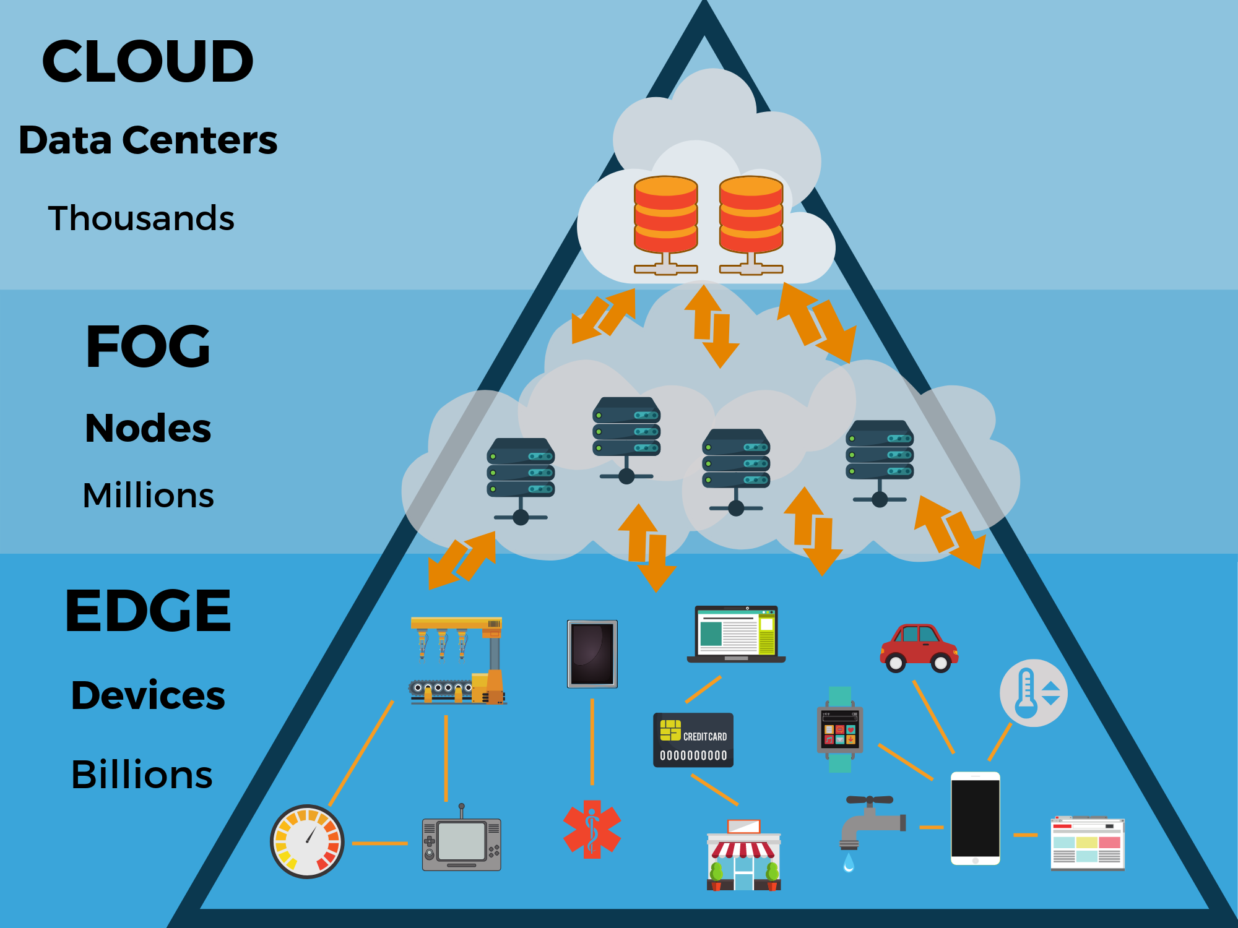

Edge computing is a paradigm of distributed computing where resources are deployed at the network's edge, allowing devices to generate and process data where it is produced. This approach minimizes the need for expensive bandwidth and enables real-time data processing. Various devices, such as mobile point-of-sale kiosks, industrial PCs, and smart cameras, can leverage edge computing to achieve faster, more accurate, and more reliable data processing [Source: Research Gate]. For instance, Apple's Face ID feature exemplifies edge computing in action, where facial recognition takes mere milliseconds due to on-device processing. In the following sections, we will explore the wide-ranging applications and advantages of edge computing in greater detail.

**Advantages of Edge Computing**

As the number of connected devices continues to escalate, data transmission between devices becomes increasingly challenging. Edge computing solutions address this issue by keeping critical data at the edge while awaiting further processing. This approach offers several advantages:

**a. Enhanced User Experiences:** Edge networks excel at providing superior user experiences by minimizing latency and bandwidth costs through the localization of essential data.

**b. Improved Security:** Edge computing bolsters security by keeping data on edge devices, making them less susceptible to cyberattacks compared to centralized data centers. Breaching an organization's network edge is more challenging.

**c. Optimization of IoT Applications:** In the rapidly expanding Internet of Things (IoT) industry, edge computing mitigates bandwidth constraints and reduces data processing time. Edge-based IoT devices enable more efficient data processing, particularly critical for applications like autonomous vehicles.

**The Challenges of Edge Computing**

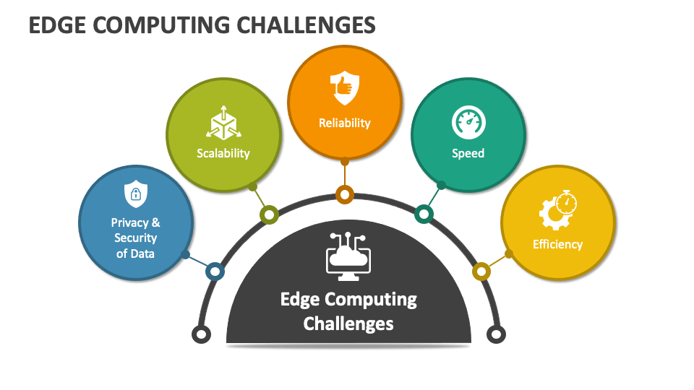

Despite its numerous advantages, edge computing presents its own set of challenges:

**a. Scalability:** Ensuring scalability over the long term is a significant challenge for edge networks, particularly in supporting a vast number of edge devices.

**b. Hardware Limitations:** Edge devices have limited hardware capacity compared to full-scale data centers, and they are also prone to hardware failures.

**c. Limited Computation Capabilities:** Edge devices, like smartphones, may struggle to host large machine learning models due to their limited computational power.

**d. Connectivity Constraints:** Edge devices depend on connectivity to central clouds, which can be problematic in remote areas, leading to network latency issues.

**Overcoming Challenges in Edge Computing**

To harness the potential of edge computing while overcoming its challenges, businesses should consider the following solutions:

**a. Connectivity Solutions:** Establish mechanisms for managing edge devices without data connectivity, ensuring backup or supplementary control and connectivity options.

**b. Security Measures:** Extend security coverage to IoT and sensor devices, implementing intrusion prevention, detection, and vulnerability management technologies.

**c. Network Administration:** Implement remote administration and management capabilities to monitor network edge functions and address concerns.

**d. Physical Maintenance:** Regular maintenance of edge devices is essential to ensure their optimal performance, including equipment and battery changes.

**Applications of Edge Computing in the Automotive Industry**

Edge computing holds immense potential in various industries, including automotive, motor insurance, healthcare, public safety, manufacturing, retail, and transportation [Source: McKinsey]. In the automotive sector, edge computing can revolutionize processes and experiences:

**a. Automated Vehicle Inspections:** Edge computing improves the efficiency and reliability of vehicle inspection processes by enabling real-time data analysis. Inspection data can be processed closer to the vehicles, facilitating quick decisions and streamlined workflows.

**b. Condition-Based Vehicle Repairs:** Real-time tracking and reporting of vehicle conditions via telematics, powered by edge computing, enables predictive maintenance schedules, accident prevention, and enhanced driving safety.

**c. Connected Cars:** Edge networks are integral to connected cars, supporting sensors and actuators to gather and analyze real-time data. Combined with advanced driver assistance systems and vehicle-to-everything (V2X) technologies, edge computing enhances connected vehicle performance.

**d. Cost Reduction:** Decentralized edge computing reduces data transmission costs and latency, making it a critical technology for cost-conscious automotive companies.

**e. User Experience:** Edge computing enhances in-vehicle infotainment systems, offering augmented reality and mobility apps, elevating the user experience.

**Downsides of Edge Computing**

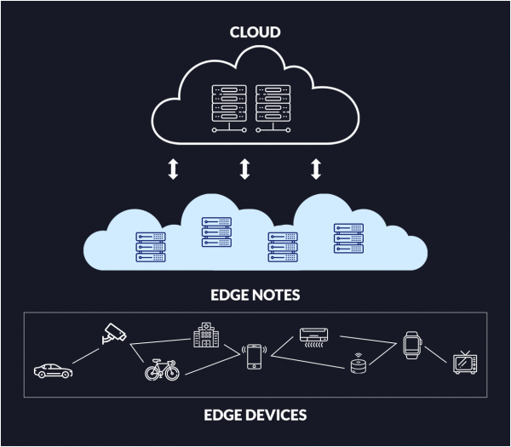

1. **Security Concerns:** Edge devices are dispersed and can be physically vulnerable, making them potential targets for attacks. Securing edge devices and ensuring data privacy at the edge can be more challenging than in centralized environments.
2. **Management Complexity:** Managing a distributed network of edge devices spread across different locations can be complex. This includes device provisioning, monitoring, software updates, and troubleshooting.
3. **Network Dependence:** Edge computing relies on network connectivity to function effectively. Network outages or latency can impact the reliability of edge applications, particularly in remote or poorly connected areas.
4. **Costs and Investments:** Deploying and maintaining edge infrastructure can involve significant upfront costs, especially for organizations with a wide geographic footprint. These costs can include hardware, software, and ongoing maintenance expenses.

**Future Prospects of Edge Computing**

1. **Enhanced AI and ML:** Edge computing is expected to drive advancements in artificial intelligence (AI) and machine learning (ML). Edge devices with AI accelerators will be able to process data locally, enabling real-time AI-driven insights without the need for continuous cloud connectivity.
2. **Green Edge Computing:** Energy efficiency and sustainability will gain importance in edge computing. Energy-efficient edge devices and data centers will be developed to reduce the environmental footprint of edge infrastructure.
3. **Autonomous Systems:** Edge computing will be critical for autonomous systems such as self-driving cars and drones. These systems require real-time data processing and decision-making capabilities that edge computing can provide.
4. **Edge Standardization:** Standardization efforts will aim to create interoperability and consistency in edge computing ecosystems. These standards will simplify device management and application development.

While edge computing has its challenges, its future prospects are promising. It will continue to evolve and play a pivotal role in enabling real-time data processing, driving innovation across industries, and supporting emerging technologies like 5G and IoT. Organizations that strategically embrace and adapt to edge computing are likely to gain a competitive advantage in the digital era.

**Conclusion**

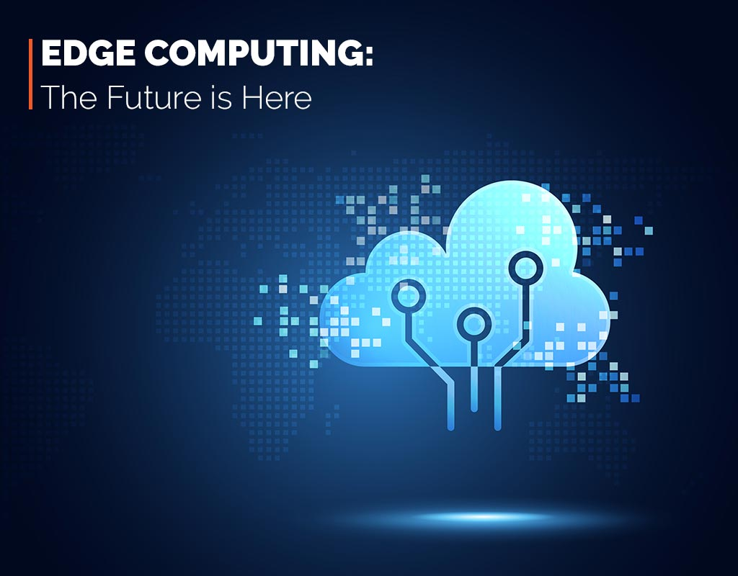

Edge computing represents a ground breaking paradigm shift in data processing and analytics, offering substantial advantages in terms of efficiency, security, and user experiences. In industries like automotive and motor insurance, edge computing promises to optimize processes, enhance safety, and revolutionize customer interactions. While challenges remain, businesses that adopt edge computing solutions and evolve their infrastructure stand to benefit significantly in a rapidly evolving technological landscape.

**Thank you…**